TASK-3

HACKERRRANK SKILL TEST
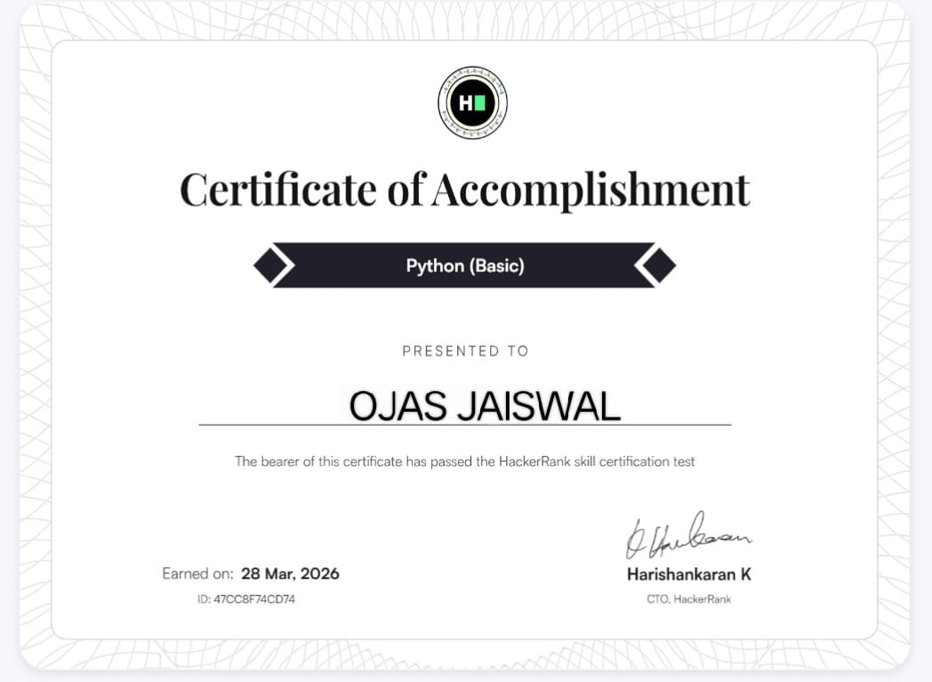
GOOGLE WORKSPACE COLLABORATION

QUIZ VIEW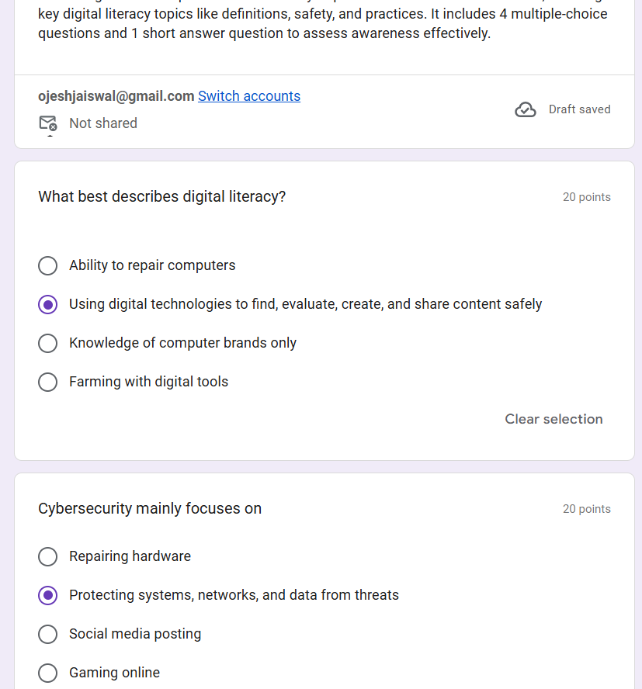
RESPONSE VIEW